
LESSON NOTE | DETAILED EXPLANATORY NOTES
BATTERY TECHNOLOGY
BIO-BATTERIES
GRADE 12 - BIOLOGY
■ ■ ■

What is a Bio-Battery?
A bio-battery is a device that produces electricity from biological materials - such as glucose (sugar), organic waste, or living microbes - using natural biochemical reactions. Like any battery, it has an anode and a cathode and drives electrons through a circuit; the difference is that the energy comes from biological fuels rather than from harsh chemicals. Bio-batteries are usually cheap, non-toxic, renewable and biodegradable.
This lesson introduces what bio-batteries are and how they work, the main types (enzymatic, microbial and plant/organic), their advantages and applications, and their potential in Papua New Guinea. Later lessons look at particular examples - paper batteries, sugar batteries and bioelectrochemical reactors.
Why Bio-Batteries Matter
- They make electricity from renewable, organic materials.
- They are non-toxic and biodegradable, unlike many ordinary batteries.
- They can turn waste (organic matter, sugars) into useful power.
- They can power small devices - sensors, and even medical implants.
Bio-Batteries
Key Learning Outcomes
By the end of this lesson, students should be able to:
- Define a bio-battery and explain how it produces electricity.
- Describe the roles of the anode, cathode and electrolyte.
- Identify the main types of bio-battery - enzymatic, microbial and plant/organic.
- Explain the oxidation–reduction (redox) idea behind a bio-battery.
- Outline the advantages, limitations and applications, including in Papua New Guinea.
How a Bio-Battery Works
A bio-battery works by the same principle as respiration in cells - releasing energy by oxidising a fuel. At the anode, a biological fuel such as glucose is oxidised, releasing electrons (e⁻) and hydrogen ions (H⁺). The electrons flow out through the external circuit - doing useful work, such as lighting a bulb - and reach the cathode, where they combine with oxygen (O₂) and H⁺ to form water. Meanwhile the H⁺ ions travel through the electrolyte to complete the circuit.

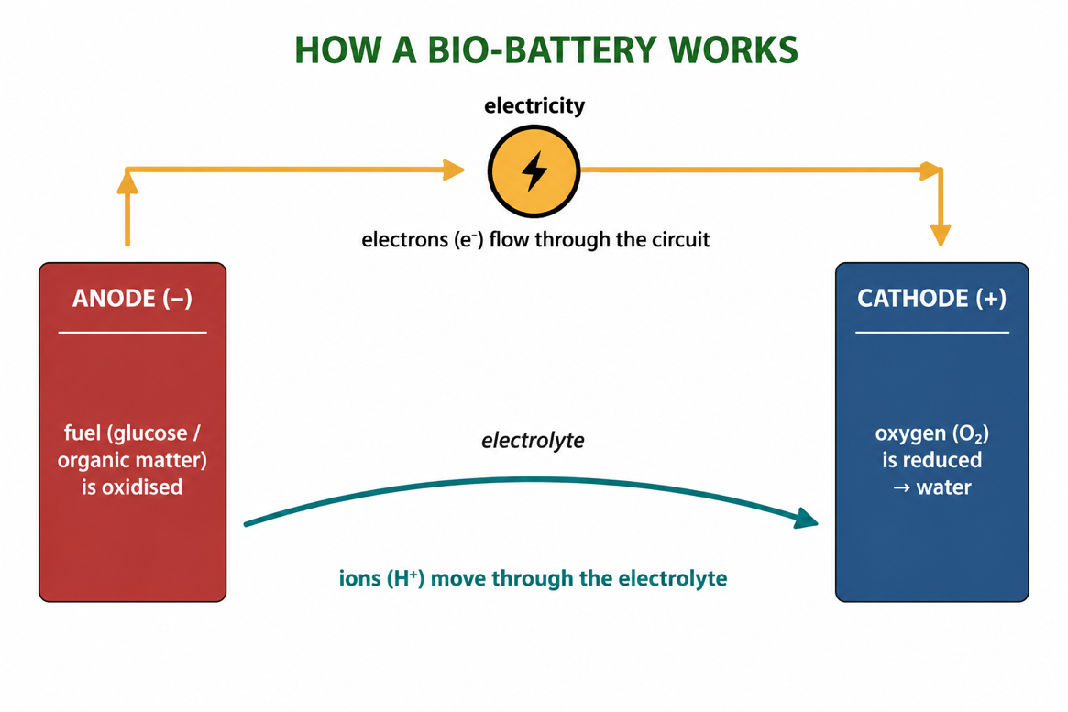
Figure 1: A bio-battery - fuel is oxidised at the anode, electrons flow through the circuit,
and oxygen is reduced to water at the cathode.
Terminologies and Concepts
Useful terms for this topic:
- Bio-battery: a device that makes electricity from biological materials.
- Anode: the electrode where the fuel is oxidised (loses electrons).
- Cathode: the electrode where oxygen is reduced (gains electrons).
- Electrolyte: the medium through which ions move between the electrodes.
- Oxidation: loss of electrons; Reduction: gain of electrons (together = redox).
- Enzyme / microbe: the biological catalyst that drives the fuel's breakdown.
- Biodegradable: able to be broken down naturally by living organisms.
Types of Bio-Batteries
Bio-batteries are grouped by what breaks down the fuel:
Enzymatic Bio-Batteries
These use enzymes as catalysts to oxidise a fuel such as glucose. They are simple and can give a lot of power for their size - the sugar battery is an example.
Microbial Bio-Batteries (Microbial Fuel Cells)
These use whole living microbes (bacteria) to break down organic matter or waste, releasing electrons to the anode. Because they can run on wastewater, they are used in bioelectrochemical reactors for water treatment.
Plant / Organic Bio-Batteries
These use plant materials such as cellulose and lignin. The paper battery is an example, using cellulose paper as part of the battery.
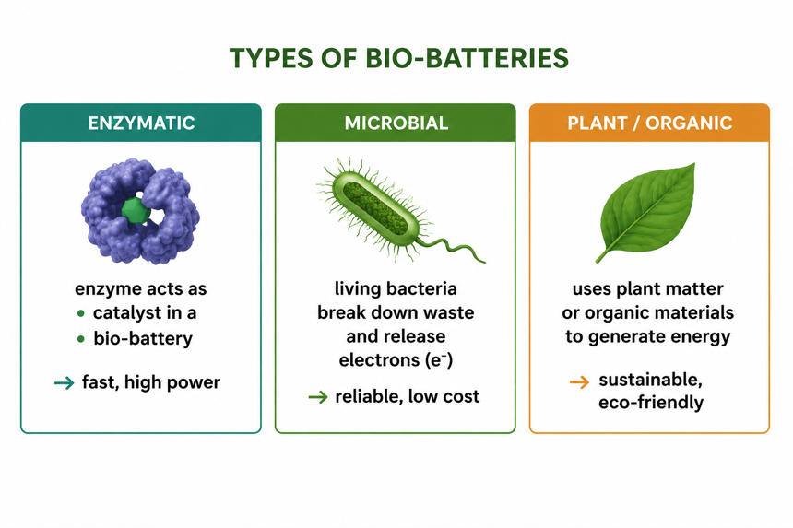
Figure 2: The three main types of bio-battery - enzymatic, microbial and plant/organic.
Applications of Bio-Batteries
Because they are small, safe and made from natural materials, bio-batteries have many possible uses:
- Medical implants - powering pacemakers and biosensors inside the body using the body's own glucose.
- Sensors - running small remote or wearable sensors.
- Portable electronics - a renewable power source for small gadgets.
- Waste-to-energy - generating electricity from organic waste and wastewater.
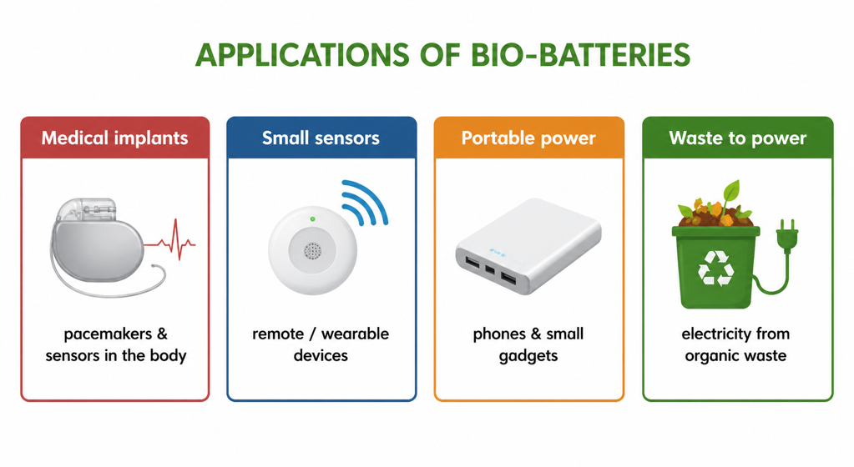
Figure 3: Applications of bio-batteries, from medical implants to turning waste into power.
Advantages and Disadvantages
Advantages | Disadvantages
Made from renewable, organic materials | Produce only small amounts of power
Non-toxic and biodegradable | Enzymes/microbes can be short-lived
Can run on waste or the body's own glucose | Still mostly developing / research technology
Cheap and simple in principle | Lower voltage than conventional batteries
Worked Example - Glucose as the Fuel
At the anode of a sugar-based bio-battery, glucose is oxidised, releasing electrons:
Glucose → gluconolactone + 2 H⁺ + 2 e⁻ (at the anode)
The electrons flow through the circuit and, at the cathode, oxygen is reduced: O₂ + 4 H⁺ + 4 e⁻ → 2 H₂O. The overall effect is that glucose and oxygen combine to release energy - the same reaction as respiration, but here the energy is captured as electricity instead of heat.
Why This Matters
- Clean power - bio-batteries turn renewable, organic fuels into electricity.
- Medicine - they could power implants safely using the body's own glucose.
- Waste - they can generate power from organic waste and dirty water.
- Sustainability - they are non-toxic and biodegradable.
PNG Context Example
Bio-batteries are attractive for Papua New Guinea because they can be built from cheap, local, organic materials - sugars from crops, plant fibres, or organic waste. Simple microbial fuel cells could one day power small sensors or LED lights in remote villages using waste or mud, and treat wastewater at the same time. As a teaching tool, a classroom bio-battery (for example a 'fruit' or 'mud' battery) is an easy, low-cost way for PNG students to see biochemistry generating electricity.
References & Related Documents
Source Documents
- STEM Biology Syllabus - Grade 12. Thema: Energy; Module 12.1 Bioenergy (Bio-Batteries). Department of Education, PNG.
- Biology Standards-Based Syllabus, Grades 11 & 12 (PNG SBC 2020) - Strand 2: Life; examine cellular respiration and the transfer of energy in living systems (oxidation–reduction reactions).
Further Reading & References
- OpenStax Biology - Cellular Respiration; Oxidation-Reduction Reactions. https://openstax.org/books/biology
- Khan Academy - Redox reactions and electrochemistry. https://www.khanacademy.org/science

